**LAB 2**

Q1) User Account

1. Create a group name ‘OSLAB02’

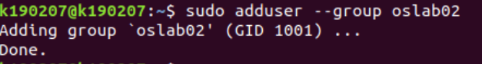

1. Create a user account ‘OSUser1’ and ‘OSUser2’ and add it to the group which is created in ‘a’

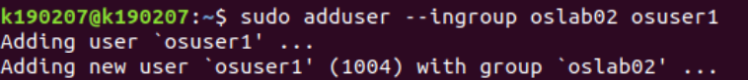

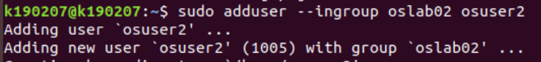

1. Also add the newly created user to group ‘sudo’



1. Login in to that user using terminal

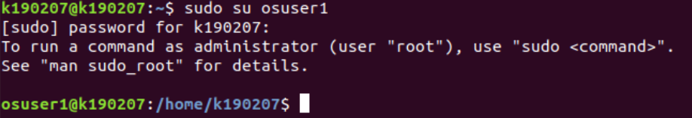

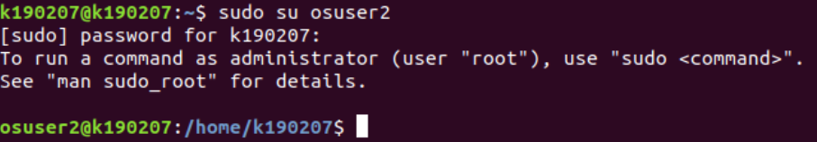

Q2) Create the following directories with one command. dirOSLAB -> subDir -> subsubdir -> OSLAB2.



Q4) Perform the following activity

1. Create user ‘abc’



1. Create a file ‘file1.txt’



1. Change the owner of the file to newly created user “abc”



1. Rename a file ‘file1.txt’



1. Create a file with timestamp



1. Make a copy of /proc directory



1. Write a command to delete non-empty directories.



1. Create a dummy file and then change the ownership of the dummy file.





1. Determine the process id of the user from which you are logged in and then terminate that process. What happens after terminating the particular process id?

j. List all files in system having string ‘lab’ in their filenames.

k. Determine the storage capacity utilized in system.

